HOW TO set up Training Events

1. The “event external link” is the correct place to enter your URL.  We must remember to put the full link in there just as Brooke did her example:  <https://events.rockwell>... Etc

               To make this link functional we have to change the Events Type to “Revere Workshops”

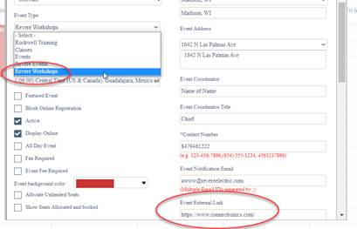

Then when we save the event, the link at the bottom of the event page goes to the external link instead of our usual sign up form.

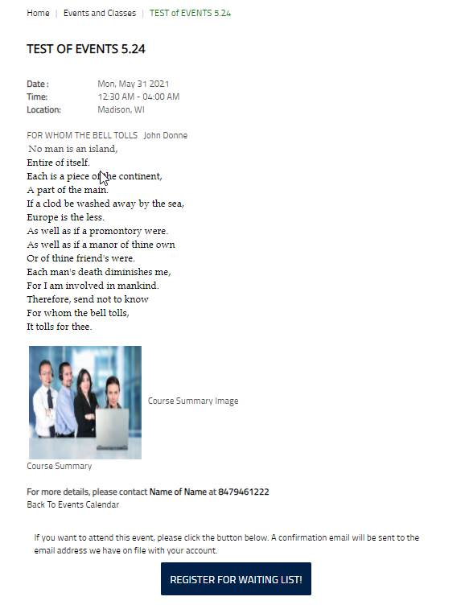

For example <https://www.revereelectric.com/eventDetailsUnit.action?eventID=3595>

At this point…  this is how I understand it to work.  It wasn’t fully explained to me, so there may be more to it.

1. Also on this event I have added the picture (the four people with headsets) which is also a link.  That is just to serve as an example of things we can do instead of the simple Course Summary image/link.  It seems we could set that up in a variety of ways.

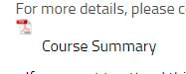

As for the wonky spacing - Keep in mind we have control over the spacing, font, colors, images,  etc of the area inside the red box of the image below.   I feel like I want it to look generally like my sample page <https://5600reb.stage.cimm2.com/testevent> but we could try anything.